

**PLANNING PROPOSAL**

**FOR**

**BATHURST REGIONAL LOCAL ENVIRONMENTAL PLAN 2014**

**AMENDMENT No 6**

**(20.00292)**

**WINDRADYNE/LLANARTH RE1-R1 ZONE BOUNDARY ALTERATION**

|  |  |  |
| --- | --- | --- |
| **Lot** | **DP** | **Address** |
| 11 | 778516 | Ophir Road, Llanarth |
| 138 | 1123180 | Governors Parade, Windradyne |

**Table of Contents**

Schedule of Maps 2

List of Attachments 3

Relevant Planning Authority Details 4

Introduction 5

Part 1 Objectives or intended outcomes 7

1.1 Introduction 7

1.2 The subject land 7

Part 2 Explanation of Provisions 9

2.1 Introduction 9

Section A – Need for the Planning Proposal 10

1. Is the Planning Proposal a result of any strategic study or report? 10

2. Is the Planning Proposal the best means of achieving the objectives or intended outcomes, or is there a better way? 10

Section B – Relationship to strategic planning framework 10

3. Is the Planning Proposal consistent with the objectives and actions of the applicable regional or sub-regional strategy (including the Sydney Metropolitan Strategy and exhibited draft strategies)? 10

4. Is the Planning Proposal consistent with a Council’s local strategy or other local strategic Plan? 11

5. Is the Planning Proposal consistent with applicable State Environmental Planning Policies? 11

6. Is the Planning Proposal consistent with applicable Ministerial Directions (s. 117 directions)? 13

Section C – Environmental , social and economic impact 17

7. Is there any likelihood that critical habitat or threatened species, populations or ecological communities, or their habitats, will be adversely affected as a result of the proposal? 17

9. Has the Planning Proposal adequately addressed any social and economic effects? 17

Section D State and Commonwealth interests 18

10. Is there adequate public infrastructure for the Planning Proposal? 18

11. What are the views of State and Commonwealth Public Authorities consulted in accordance with the Gateway Determination? 18

Part 4 Mapping 19

Part 5 Community Consultation 20

Part 6 Project timeframe 21

Attachment 1 Location plan 22

Attachment 2 Council report and minute 23

# Schedule of Maps

|  |  |  |
| --- | --- | --- |
| **Map Number** | **Map Name** | **Version** |
| LZN_011A | Land zone Map – Sheet LZN_011A | A |
| LZN_011B | Land zone Map – Sheet LZN_011B | A |
| LSZ_011A | Lot size Map – Sheet LSZ_011A | A |
| LSZ_011B | Lot size Map – Sheet LSZ_011B | A |
| HOB_011A | Height of buildings Map – Sheet HOB_011A | A |
| HOB_011B | Height of buildings Map – Sheet HOB_011B | A |
| LSM_011A | Minimum Lot Size - Multi Dwelling Housing & Residential Flat Buildings Map – Sheet LSM_0 11A | A |
| LSM_011B | Minimum Lot Size - Multi Dwelling Housing & Residential Flat Buildings Map – Sheet LSM_0 11B | A |
| LSD_011A | Minimum Lot Size - Dual Occupancy Map - Sheet LSD_011A | A |
| LSD_011B | Minimum Lot Size - Dual Occupancy Map - Sheet LSD_011B | A |
| LRA_011A | Land Reservation Acquisition Map - Sheet LRA_011A | A |
| LRA_011B | Land Reservation Acquisition Map - Sheet LRA_011B | A |

# List of Attachments

|  |  |
| --- | --- |
| **Attachment Number** | **Name** |
| 1 | Location Plan |
| 2 | Council report and minute to proceed with the Planning Proposal |

# Relevant Planning Authority Details

|  |  |
| --- | --- |
| **Relevant Planning Authority:** | Bathurst Regional Council |
| **Contact Person:** | Ms Janet Bingham  Acting Director,  Environmental Planning and Building Services |
| **Contact Phone Number:** | 02 6333 6213 |
| **Contact email address:** | [janet.bingham@bathurst.nsw.gov.au](mailto:janet.bingham@bathurst.nsw.gov.au) |

# Introduction

Council has received two requests to consider an alteration to the Bathurst Regional Local Environmental Plan with respect to the R1 General Residential and RE1 Local Recreation zone interface in Windradyne and Llanarth. A location plan is included at **attachment 1.**

Site 1 – Lot 11 DP 778516, Ophir Road, Llanarth

Council has previously issued development consent for a residential subdivision comprising 18 residential lots and 2 open space lots under Council’s previous LEP, the land being zoned residential with open space restrictions applying under the DCP. The approval retained two existing dwellings on two of the 18 proposed residential lots despite those lots now being zoned recreation. Thus that part of the open space land would not have been dedicated to Council.

Council has received a request from the current landowner for it to consider an amended lot layout to cater for a multi-unit development on proposed lot 16. The amended lot layout is predicated on the need for a RE1/R1 zone boundary alteration. It is proposed to rezone an area on the southern boundary from RE1 Local Recreation to R1 General Residential and rezone land at the north of the site from R1 to RE1. Currently approximately 9240 sqm is zoned RE1, and following the proposed rezoning approximately 9623 sqm will be zoned RE1. This will result in an overall increase of 383 sqm of recreation land.

The existing two houses will remain on the land zoned recreation however the development now proposes to demolish the two existing houses and dedicate the land to Council.

In this circumstance, ie the overall gain of recreation land, the demolition of the two dwellings in the open space, and the maintenance of an appropriate buffer to Sawpit Creek, the planning proposal should be supported.

Site 2 – Lot 138 DP 1123180, Governors Parade, Windradyne

It should be noted that Bathurst Regional Council is the owner of this particular lot.

Council’s Windradyne 1001 subdivision is currently being designed. The final design has responded to the features of the land and has resulted in a number of proposed lots being located partially within the RE1 Local Recreation zone, and two lots wholly within the RE1 zone. It is proposed to rezone an area of approximately 0.68 hectares on the western boundary from RE1 Local Recreation to R1 General Residential. It is also proposed to rezone approximately 4 hectares from R1 General Residential to RE1 Local Recreation. This will result in an overall increase of approximately 3.32 hectares of Recreation land. A 50 metre buffer will be retained to the adjoining rural zoned land to the west.

In this circumstance, ie the overall gain of recreation land, the planning proposal should be supported.

A copy of the Council report and minute to proceed with the Planning Proposal are provided at **attachment 2**.

If the Planning Panel so determines, Council will accept the delegated functions offered to it pursuant to Section 59 of the Environmental Planning and Assessment Act 1979.

The Planning Proposal has been prepared in accordance with Section 55 of *the Environmental Planning and Assessment Act 1979* (the Act) and the relevant Department of Planning Guidelines, including *A Guide to Preparing Local Environmental Plans* and *A Guide to Preparing Planning Proposals*.

Part 1 Objectives or intended outcomes

## 1.1 Introduction

The aim of the Planning Proposal is to alter the R1 Residential / RE1 Local Recreation zone interface in the suburbs of Windradyne and Llanarth in response to development specific requests.

## 1.2 The subject land

Site 1 – Lot 11 DP 778516, Ophir Road, Llanarth

The subject land comprises Lot 11 DP 778516, Ophir Road Llanarth. The property is in private ownership.

The site is approximately 3 hectares and is generally rectangular in shape. The land is located approximately 5km north west of the Bathurst CBD.

The land currently has the following characteristics:

|  |  |  |  |
| --- | --- | --- | --- |
| **Current land use** | **Zone**  **Bathurst Regional LEP 2014** | **Current classification** | **Land status** |
| 3 x dwellings and associated outbuildings | R1 Residential and RE1 Local Recreation | n/a | n/a |

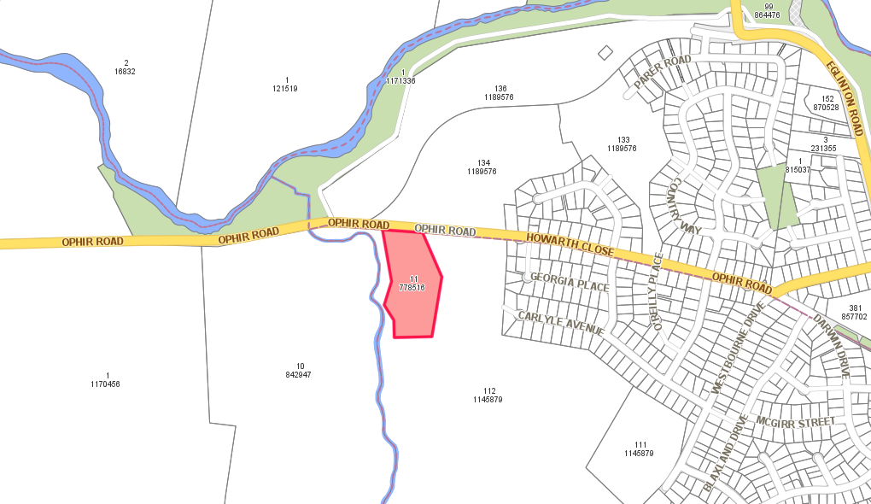

Site 2 – Lot 138 DP 1123180, Governors Parade, Windradyne

The subject land comprises Lot 138 DP 1123180, Governors Parade, Windradyne. The property is owned by Bathurst Regional Council as part of its land development activities.

The site is approximately 40.24 hectares and is generally rectangular in shape. The land is located approximately 4km west of the Bathurst CBD.

The land currently has the following characteristics:

|  |  |  |  |
| --- | --- | --- | --- |
| **Current land use** | **Zone**  **Bathurst Regional LEP 2014** | **Current classification** | **Land status** |
| Agricultural | R1 Residential and RE1 Local Recreation | n/a | n/a |

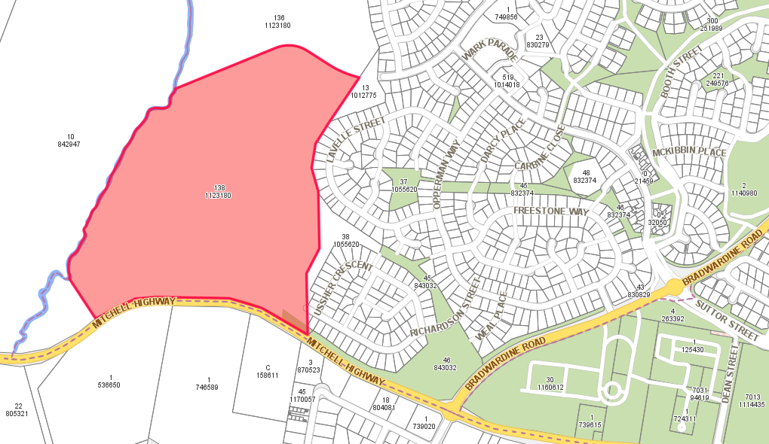

# Part 2 Explanation of Provisions

## 2.1 Introduction

The aim of the Planning Proposal is to alter the R1 Residential / RE1 Local Recreation zone interface in the suburbs of Windradyne and Llanarth in response to development specific requests.

Site 1 – Lot 11 DP 778516, Ophir Road, Llanarth

It is proposed to rezone an area on the southern boundary from RE1 Local Recreation to R1 General Residential and rezone land at the north of the site from R1 to RE1. Currently approximately 9240 sqm is zoned RE1, and following the proposed rezoning approximately 9623 sqm will be zoned RE1. This will result in an overall increase of 383 sqm of recreation land.

Supporting the rezoning of the land, amendments to the following maps will also occur imposing the appropriate controls on the land:

* Minimum Lot Size—Dual Occupancy Map
* Height of Buildings Map
* Minimum Lot Size—Multi Dwelling Housing and Residential Flat Buildings Map
* Lot Size Map
* Land Reservation Acquisition Map

Site 2 – Lot 138 DP 1123180, Governors Parade, Windradyne

It is proposed to rezone an area of approximately 0.68 hectares on the western boundary from RE1 Local Recreation to R1 General Residential. It is also proposed to rezone approximately 4 hectares from R1 General Residential to RE1 Local Recreation. This will result in an overall increase of approximately 3.32 hectares of Recreation land. A 50 metre buffer will be retained to the adjoining rural zoned land to the west.

Supporting the rezoning of the land, amendments to the following maps will also occur imposing the appropriate controls on the land:

* Minimum Lot Size—Dual Occupancy Map
* Height of Buildings Map
* Minimum Lot Size—Multi Dwelling Housing and Residential Flat Buildings Map
* Lot Size Map
* Land Reservation Acquisition Map

Alterations to Council’s DCP in relation to these sites is proposed to occur concurrently with the exhibition of the Planning Proposal.PART 3 Justification

## Section A – Need for the Planning Proposal

### 1. Is the Planning Proposal a result of any strategic study or report?

No. In both cases (sites 1 & 2) the Planning Proposal is in response to landowner requests. In both cases, the request relates to altering the R1 Residential / RE1 Local Recreation zone boundary to cater for development specific requests.

On balance, the amount of open space in both locations increases.

Council has subsequently resolved on 16 September 2015 to prepare a planning proposal to reclassify the subject land.

### 2. Is the Planning Proposal the best means of achieving the objectives or intended outcomes, or is there a better way?

The Planning Proposal is the best means of achieving the development and intended outcomes of the Planning Proposal. The only avenue available to Council to rezone the land is via a Planning Proposal.

## Section B – Relationship to strategic planning framework

### 3. Is the Planning Proposal consistent with the objectives and actions of the applicable regional or sub-regional strategy (including the Sydney Metropolitan Strategy and exhibited draft strategies)?

The following table addresses the evaluation criteria for the consistency with the regional and sub-regional strategies, as required by the guidelines for preparing a Planning Proposal.

|  |  |  |
| --- | --- | --- |
| **Evaluation criteria** | **Y/N** | **Comment** |
| Does the proposal have strategic merit and:   * Is consistent with a relevant local strategy endorsed by the Director General; or * Is consistent with the relevant regional strategy or Metropolitan Plan; or * Can it demonstrate strategic merit, giving consideration to the relevant section 117 directions applying to the site and other strategic considerations (e.g. proximity to existing urban areas , public transport and infrastructure accessibility, providing jobs closer to home etc) | Yes | The lots have historically been zoned for residential purposes over a number of decades. The Bathurst Regional LEP 2014, for the first time, zoned open space in suburban locations. The Planning Proposal aims to amend the R1/RE1 zone interface catering for development specific circumstances. The Planning Proposal is consistent with the Bathurst Region Urban Strategy.  There are no relevant regional strategies relevant to the Bathurst Regional LGA.  The Planning Proposal is consistent with the relevant Section 117 directions of the Minister. They are explained later in this Planning Proposal documentation. |
| Does the proposal have site specific merit and is it compatible with the surrounding land uses, having regard to the following:   * The natural environment (including known significant environmental values, resources or hazards) and * The existing uses, approved uses and likely future uses of the land in the vicinity of the proposal; and * The services and infrastructure that are or will be available to meet the demands arising from the proposal and any proposed financial arrangements for infrastructure provision. | Yes | Notwithstanding the alteration to the R1/RE1 zone boundary interface, following the proposed rezoning, the amount of open space is expected to increase overall.  The site is not known to have any environmental constraints and the site is not bush fire prone land. |

### 4. Is the Planning Proposal consistent with a Council’s local strategy or other local strategic Plan?

The Bathurst Region Urban Strategy 2007 identified this area for continued growth of the city. Therefore the Planning Proposal is consistent with the strategy. The land in its current form has been zoned for residential purposes for a number of decades and is located adjacent to existing residential estates. The alteration of the open space arrangements, particularly given the increase in the amount of open space overall should be supported. Buffers to rural lands and open space corridors remain consistent with the recommendations of the Bathurst Region Urban Strategy.

### 5. Is the Planning Proposal consistent with applicable State Environmental Planning Policies?

Council has undertaken a review to determine whether or not the Planning Proposal is consistent with the State Environmental Planning Policies. There are no SEPP’s which are relevant to the Planning Proposal. See the table below.

|  |  |
| --- | --- |
| **State Environmental Planning Policy (SEPP)** | **Compliance (Yes/No or  Not Relevant)** |
| SEPP No 14 – Coastal Wetlands | **Not Relevant** |
| SEPP No 15 – Rural Landsharing Communities | **Not Relevant** |
| SEPP No 19 – Bushland in Urban Areas | **Not Relevant** |
| SEPP No 21 – Caravan Parks | **Not Relevant** |
| SEPP No 22 – Shops and Commercial Premises | **Not Relevant** |
| SEPP No 26 – Littoral Rainforests | **Not Relevant** |
| SEPP No 29 – Western Sydney Recreation Area | **Not Relevant** |
| SEPP No 30 – Intensive Agriculture | **Not Relevant** |
| SEPP No 32 – Urban Consolidation (Redevelopment of Urban Land) | **Not Relevant** |
| SEPP No 33 – Hazardous and Offensive Development | **Not Relevant** |
| SEPP No 36 – Manufactured Home Estates | **Not Relevant** |
| SEPP No 39 – Spit Island Bird Habitat | **Not Relevant** |
| SEPP No 41 – Casino Entertainment Complex | **Not Relevant** |
| SEPP No 44 – Koala Habitat Protection | **Not Relevant** |
| SEPP No 47 – Moore Park Showground | **Not Relevant** |
| SEPP No 50 – Canal Estate Development | **Not Relevant** |
| SEPP No 52 – Farm Dams and Other Works in Land and Water Management Plan Areas | **Not Relevant** |
| SEPP No 55 – Remediation of Land | **Not Relevant** |
| SEPP No 59 – Central Western Sydney Regional Open Space and Residential | **Not Relevant** |
| SEPP No 60 – Exempt and Complying Development | **Not Relevant** |
| SEPP No 62 – Sustainable Aquaculture | **Not Relevant** |
| SEPP No 64 – Advertising and Signage | **Not Relevant** |
| SEPP No 65 – Design Quality of Residential Flat Development | **Not Relevant** |
| SEPP No 70 – Affordable Housing (Revised Schemes) | **Not Relevant** |
| SEPP No 71 – Coastal Protection | **Not Relevant** |
| SEPP (Affordable Rental Housing) 2009 | **Not Relevant** |
| SEPP (Building Sustainability Index: BASIX) 2004 | **Not Relevant** |
| SEPP (Exempt and Complying Development Codes) 2008 | **Not Relevant** |
| SEPP (Housing for Seniors or People with a Disability)2004 | **Not Relevant** |
| SEPP (Infrastructure) 2007 | **Not Relevant** |
| SEPP (Kosciuszko National Park – Alpine Resorts) 2007 | **Not Relevant** |
| SEPP (Kurnell Peninsula) 1989 | **Not Relevant** |
| SEPP (Major Development) 2005 | **Not Relevant** |
| SEPP (Mining, Petroleum Production and Extractive Industries) 2007 | **Not Relevant** |
| SEPP (Penrith Lakes Scheme) 1989 | **Not Relevant** |
| SEPP (Rural Lands) 2008 | **Not Relevant** |
| SEPP (SEPP 53 Transitional Provisions) 2011 | **Not Relevant** |
| SEPP (State and Regional Development) 2011 | **Not Relevant** |
| SEPP (Sydney Water Drinking Catchment) 2011 | **Not Relevant** |
| SEPP (Sydney Region Growth Centres) 2006 | **Not Relevant** |
| SEPP (Temporary Structures) 2007 | **Not Relevant** |
| SEPP (Urban Renewal) 2010 | **Not Relevant** |
| SEPP (Western Sydney Employment Area) 2009 | **Not Relevant** |
| SEPP (Western Sydney Parklands) 2009 | **Not Relevant** |

### 6. Is the Planning Proposal consistent with applicable Ministerial Directions (s. 117 directions)?

Council has undertaken a review to ensure the planning proposal is consistent with all relevant Section 117 Ministerial Directions issued by the Minister for Planning to relevant planning authorities under section 117(2) of the *Environmental Planning and Assessment Act 1979.*

All relevant Section 117 Ministerial Directions are considered in the following table.

| **Section 117 Ministerial Direction** | **Consistency** |
| --- | --- |
| **1. Employment and resources** | |
| 1.1 Business and Industrial Zones | Not applicable.  **Council is satisfied that the planning proposal is consistent with the requirements of the direction.** |
| 1.2 Rural Zones | Not applicable.  **Council is satisfied that the planning proposal is consistent with the requirements of the direction.** |
| 1.3 Mining, Petroleum Production and Extractive Industries | Not applicable.  **Council is satisfied that the planning proposal is consistent with the requirements of the direction.** |
| 1.4 Oyster Aquaculture | Not applicable.  **Council is satisfied that the planning proposal is consistent with the requirements of the direction.** |
| 1.5 Rural Lands | Not applicable.  **Council is satisfied that the planning proposal is consistent with the requirements of the direction.** |
| **2. Environment and Heritage** | |
| 2.1 Environment Protection Zones | Not applicable.  **Council is satisfied that the planning proposal is consistent with the requirements of the direction.** |
| 2.2 Coastal Protection | Not applicable.  **Council is satisfied that the planning proposal is consistent with the requirements of the direction.** |
| 2.3 Heritage Conservation | Not applicable.  **Council is satisfied that the planning proposal is consistent with the requirements of the direction.** |
| 2.4 Recreation Vehicle Areas | Not applicable.  **Council is satisfied that the planning proposal is consistent with the requirements of the direction.** |
| **3. Housing, Infrastructure and Urban Development** | |
| 3.1 Residential Zones | Not applicable.  **Council is satisfied that the planning proposal is consistent with the requirements of the direction as the zone of the land is not being altered.** |
| 3.2 Caravan Parks and Manufactured Home Estates | Not applicable.  **Council is satisfied that the planning proposal is consistent with the requirements of the direction.** |
| 3.3 Home Occupations | Not applicable.  **Council is satisfied that the planning proposal is consistent with the requirements of the direction.** |
| 3.4 Integrating Land Use and Transport | Not applicable.  **Council is satisfied that the planning proposal is consistent with the requirements of the direction.** |
| 3.5 Development Near Licensed Aerodromes | The proposal does not alter or remove a provision relating to land in the vicinity of a licensed aerodrome.  **Council is satisfied that the planning proposal is consistent with the requirements of the direction.** |
| 3.6 Shooting Ranges | The proposal does not affect land adjacent or adjoining an existing shooting range.  **Council is satisfied that the planning proposal is consistent with the requirements of the direction.** |
| **4. Hazard and Risk** | |
| 4.1 Acid Sulfate Soils | The Bathurst Region does not include any land identified on Acid Sulfate Soils Planning maps held by the Department.  **Council is satisfied that the planning proposal is consistent with the requirements of the direction.** |
| 4.2 Mine Subsidence and Unstable Land | The Bathurst Region does not include any land identified as within a Mine Subsidence District proclaimed under the Mine Subsidence Compensation Act 1961.  **Council is satisfied that the planning proposal is consistent with the requirements of the direction.** |
| 4.3 Flood Prone Land | The Planning Proposal does not include any land which is identified as being flood liable land as identified either by Council’s computer based flood model or the Bathurst Floodplain Management Policy.  **Council is satisfied that the planning proposal is consistent with the requirements of the direction.** |
| 4.4 Planning for Bushfire Protection | The Planning Proposal does not include any land which is identified as being Bushfire Prone Land.  **Council is satisfied that the planning proposal is consistent with the requirements of the direction.** |
| **5. Regional Planning** | |
| 5.1 Implementation of Regional Strategies | No regional or sub-regional strategy applies to the Bathurst Region.  **Council is satisfied that the planning proposal is consistent with the requirements of the direction.** |
| 5.2 Sydney Drinking Water Catchments | The Bathurst Region is outside the identified Sydney Drinking Water Catchment area.  **Council is satisfied that the planning proposal is consistent with the requirements of the direction.** |
| 5.3 Farmland of State and Regional Significance on the NSW Far North Coast | Does not apply to the Bathurst Region.  No farmland of State or Regional significance is located within the Bathurst Region.  **Council is satisfied that the planning proposal is consistent with the requirements of the direction.** |
| 5.4 Commercial and Retail; Development along the Pacific Highway, North Coast | Does not apply to the Bathurst Region.  No regional or sub-regional strategy applies to the Bathurst Region.  **Council is satisfied that the planning proposal is consistent with the requirements of the direction.** |
| 5.8 Second Sydney Airport: Badgerys Creek | Does not apply to the Bathurst Region.  No regional or sub-regional strategy applies to the Bathurst Region.  **Council is satisfied that the planning proposal is consistent with the requirements of the direction.** |
| 5.9 North West Rail Link Corridor Strategy | Does not apply to the Bathurst Region.  **Council is satisfied that the planning proposal is consistent with the requirements of the direction.** |
| **6. Local Plan Making** | |
| 6.1  Approval and referral Requirements | The Planning Proposal does not affect development application provisions and does not propose any referral provisions relating to this land.  **Council is satisfied that the planning proposal is consistent with the requirements of the direction.** |
| 6.2  Reserving land for Public Purposes | The Planning Proposal does not relate to reserving land for public purposes.  The Planning proposal involves altering the R1 / RE1 zone interface, and as yet, has not been dedicated to Council for public purposes. Council is satisfied that the overall amount of open space is increasing in the locality which will be of benefit to the community as a whole.  **Council is satisfied that the planning proposal is consistent with the requirements of the direction.** |
| 6.3  Site Specific Provisions | The Planning Proposal does not relate to a particular development to be carried out on a specific site.  **Council is satisfied that the planning proposal is consistent with the requirements of the direction.** |
| **7. Metropolitan Planning** | |
| 7.1 Implementation of the Metropolitan Strategy | Does not apply to the Bathurst Region.  **Council is satisfied that the planning proposal is consistent with the requirements of the direction.** |

## Section C – Environmental , social and economic impact

### 7. Is there any likelihood that critical habitat or threatened species, populations or ecological communities, or their habitats, will be adversely affected as a result of the proposal?

Council is satisfied that, as a result of the Planning Proposal, critical habitat, threatened species, populations or ecological communities will not be adversely affected by the reclassification.

8. Are there any other likely environmental effects as a result of the Planning Proposal and how are they proposed to be managed?

Council considers that there are no likely environmental effects as a result of the Planning Proposal. Appropriate buffers to rural lands and creek corridors have been maintained.

### 9. Has the Planning Proposal adequately addressed any social and economic effects?

Social Impacts

It is considered that as a result of the Planning Proposal there are no social impacts that need to be addressed.

Economic Impacts

It is considered that as a result of the Planning Proposal there are no economic impacts that need to be addressed.

## Section D State and Commonwealth interests

### 10. Is there adequate public infrastructure for the Planning Proposal?

The Planning Proposal does not impact on any existing or future public infrastructure.

### 11. What are the views of State and Commonwealth Public Authorities consulted in accordance with the Gateway Determination?

Council has not consulted with any Government Agencies. Council does not propose to consult with any State or Commonwealth Public Authority as the Planning Proposal only involves a boundary adjustment between the existing residential and recreation zone.

# Part 4 Mapping

The following maps are proposed to be amended as a result of this planning proposal.

|  |  |  |
| --- | --- | --- |
| **Map Number** | **Map Name** | **Version** |
| LZN_011A | Land zone Map – Sheet LZN_011A | A |
| LZN_011B | Land zone Map – Sheet LZN_011B | A |
| LSZ_011A | Lot size Map – Sheet LSZ_011A | A |
| LSZ_011B | Lot size Map – Sheet LSZ_011B | A |
| HOB_011A | Height of buildings Map – Sheet HOB_011A | A |
| HOB_011B | Height of buildings Map – Sheet HOB_011B | A |
| LSM_011A | Minimum Lot Size - Multi Dwelling Housing & Residential Flat Buildings Map – Sheet LSM_0 11A | A |
| LSM_011B | Minimum Lot Size - Multi Dwelling Housing & Residential Flat Buildings Map – Sheet LSM_0 11B | A |
| LSD_011A | Minimum Lot Size - Dual Occupancy Map - Sheet LSD_011A | A |
| LSD_011B | Minimum Lot Size - Dual Occupancy Map - Sheet LSD_011B | A |
| LRA_011A | Land Reservation Acquisition Map - Sheet LRA_011A | A |
| LRA_011B | Land Reservation Acquisition Map - Sheet LRA_011B | A |

# Part 5 Community Consultation

Council anticipates that following the Gateway Determination and Council satisfying any conditions imposed prior to the public exhibition period, the Planning Proposal will be placed on public exhibition for a period of 28 days.

It is proposed that the Planning Proposal will be publically notified by:

1. a notice in the Western Advocate newspaper on at least 2 occasions; and
2. written notification to all of the directly adjoining landowners; and
3. notification on Council’s website.

A Public Hearing is not expected to be conducted as part of this Planning Proposal.

If the Planning Panel deems necessary, Council will notify any relevant government public authorities concurrently with the public exhibition period with respect to the Planning Proposal.

Following the public exhibition period, this section will be altered to reflect the extent of consultation that was undertaken, including any issues which were raised as a result of the consultation.

# Part 6 Project timeframe

The following table outlines Council’s anticipated timetable for the completion of the Planning Proposal. Council anticipates that the process will take approximately 8 months from the date of the Gateway Determination.

|  |  |  |
| --- | --- | --- |
| **Step** | **Criteria** | **Project timeline** |
| 1 | Anticipated commencement date (date of Gateway determination) | November 2015 |
| 2 | Anticipated timeframe for the completion of required technical information | November 2015 |
| 3 | Timeframe for government agency consultation (pre and post exhibition as required by Gateway determination) | Not relevant |
| 4 | Commencement and completion dates for public exhibition period | February 2016 |
| 5 | Dates for public hearing (if required) | Not relevant |
| 6 | Timeframe for consideration of submissions | March 2016 |
| 7 | Timeframe for the consideration of a proposal post exhibition | March 2016 |
| 8 | Date of submission to the department to finalise the LEP | April 2016 |
| 9 | Anticipated date RPA will make the plan (if delegated) | May 2016 |
| 10 | Anticipated date RPA will forward to the department for notification. | May 2016 |

# Attachment 1 Location plan

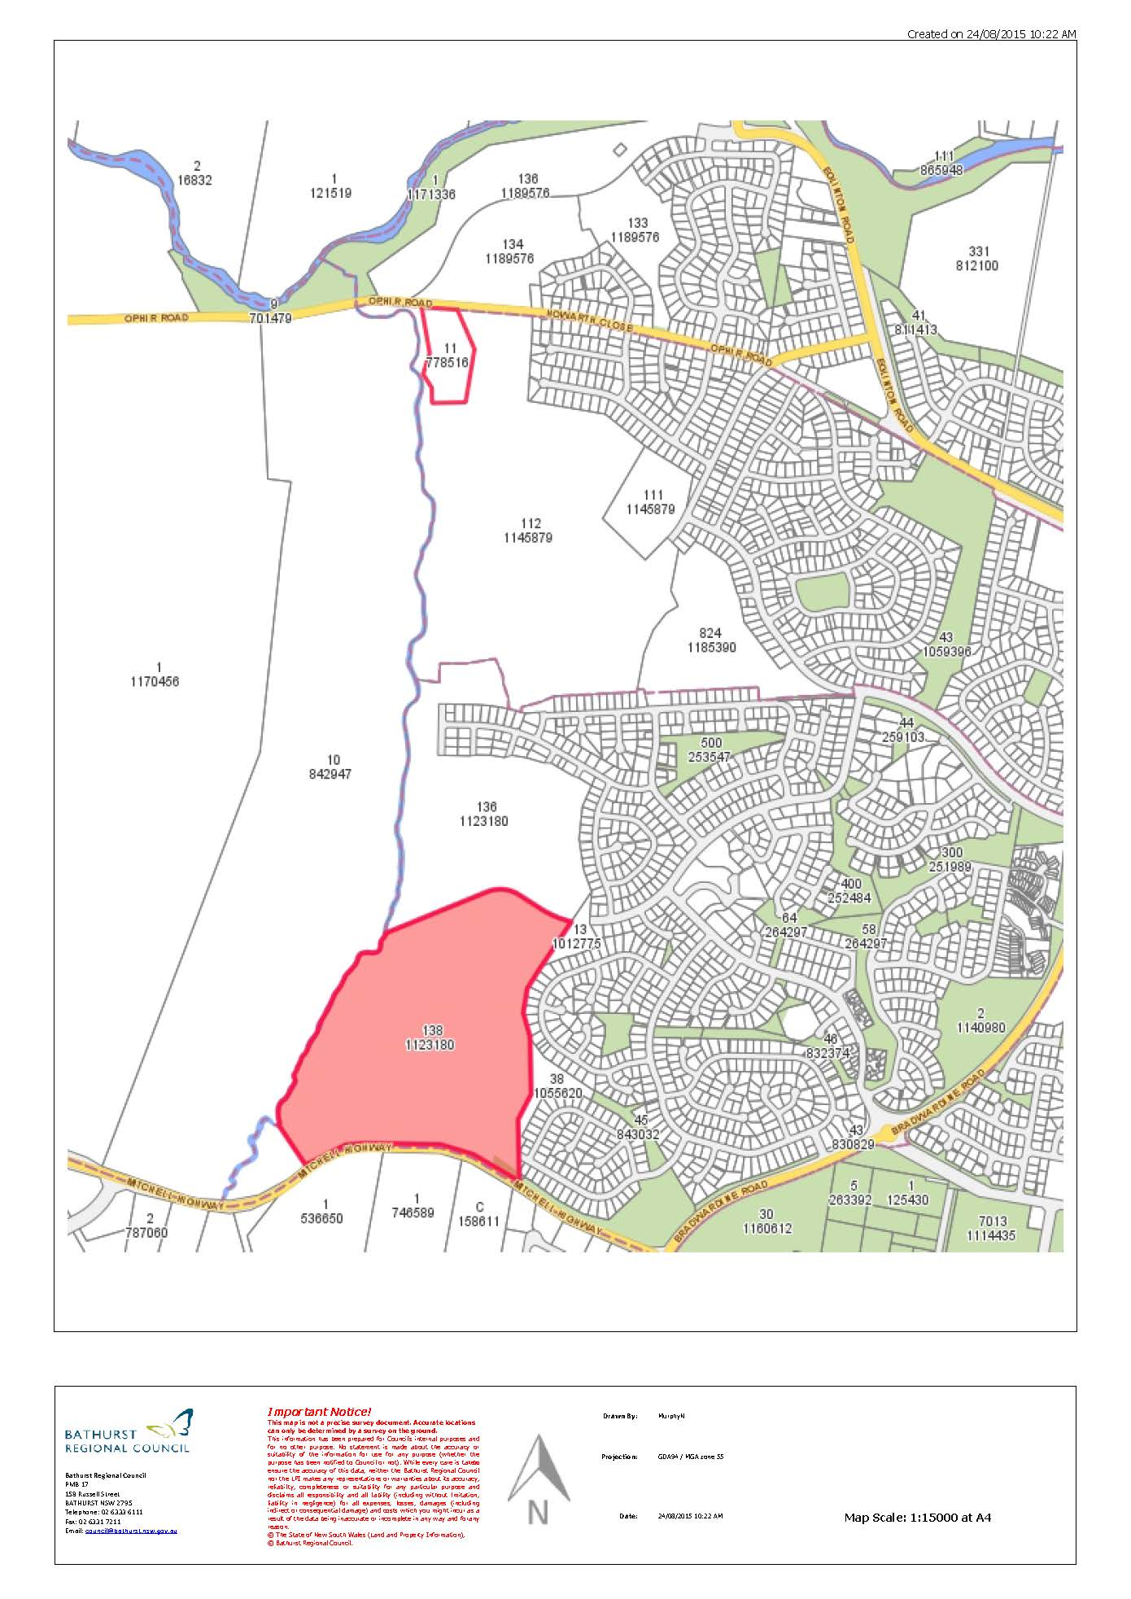

# Attachment 2 Council report and minute

Bathurst Regional Council Ordinary Meeting 16 September 2015

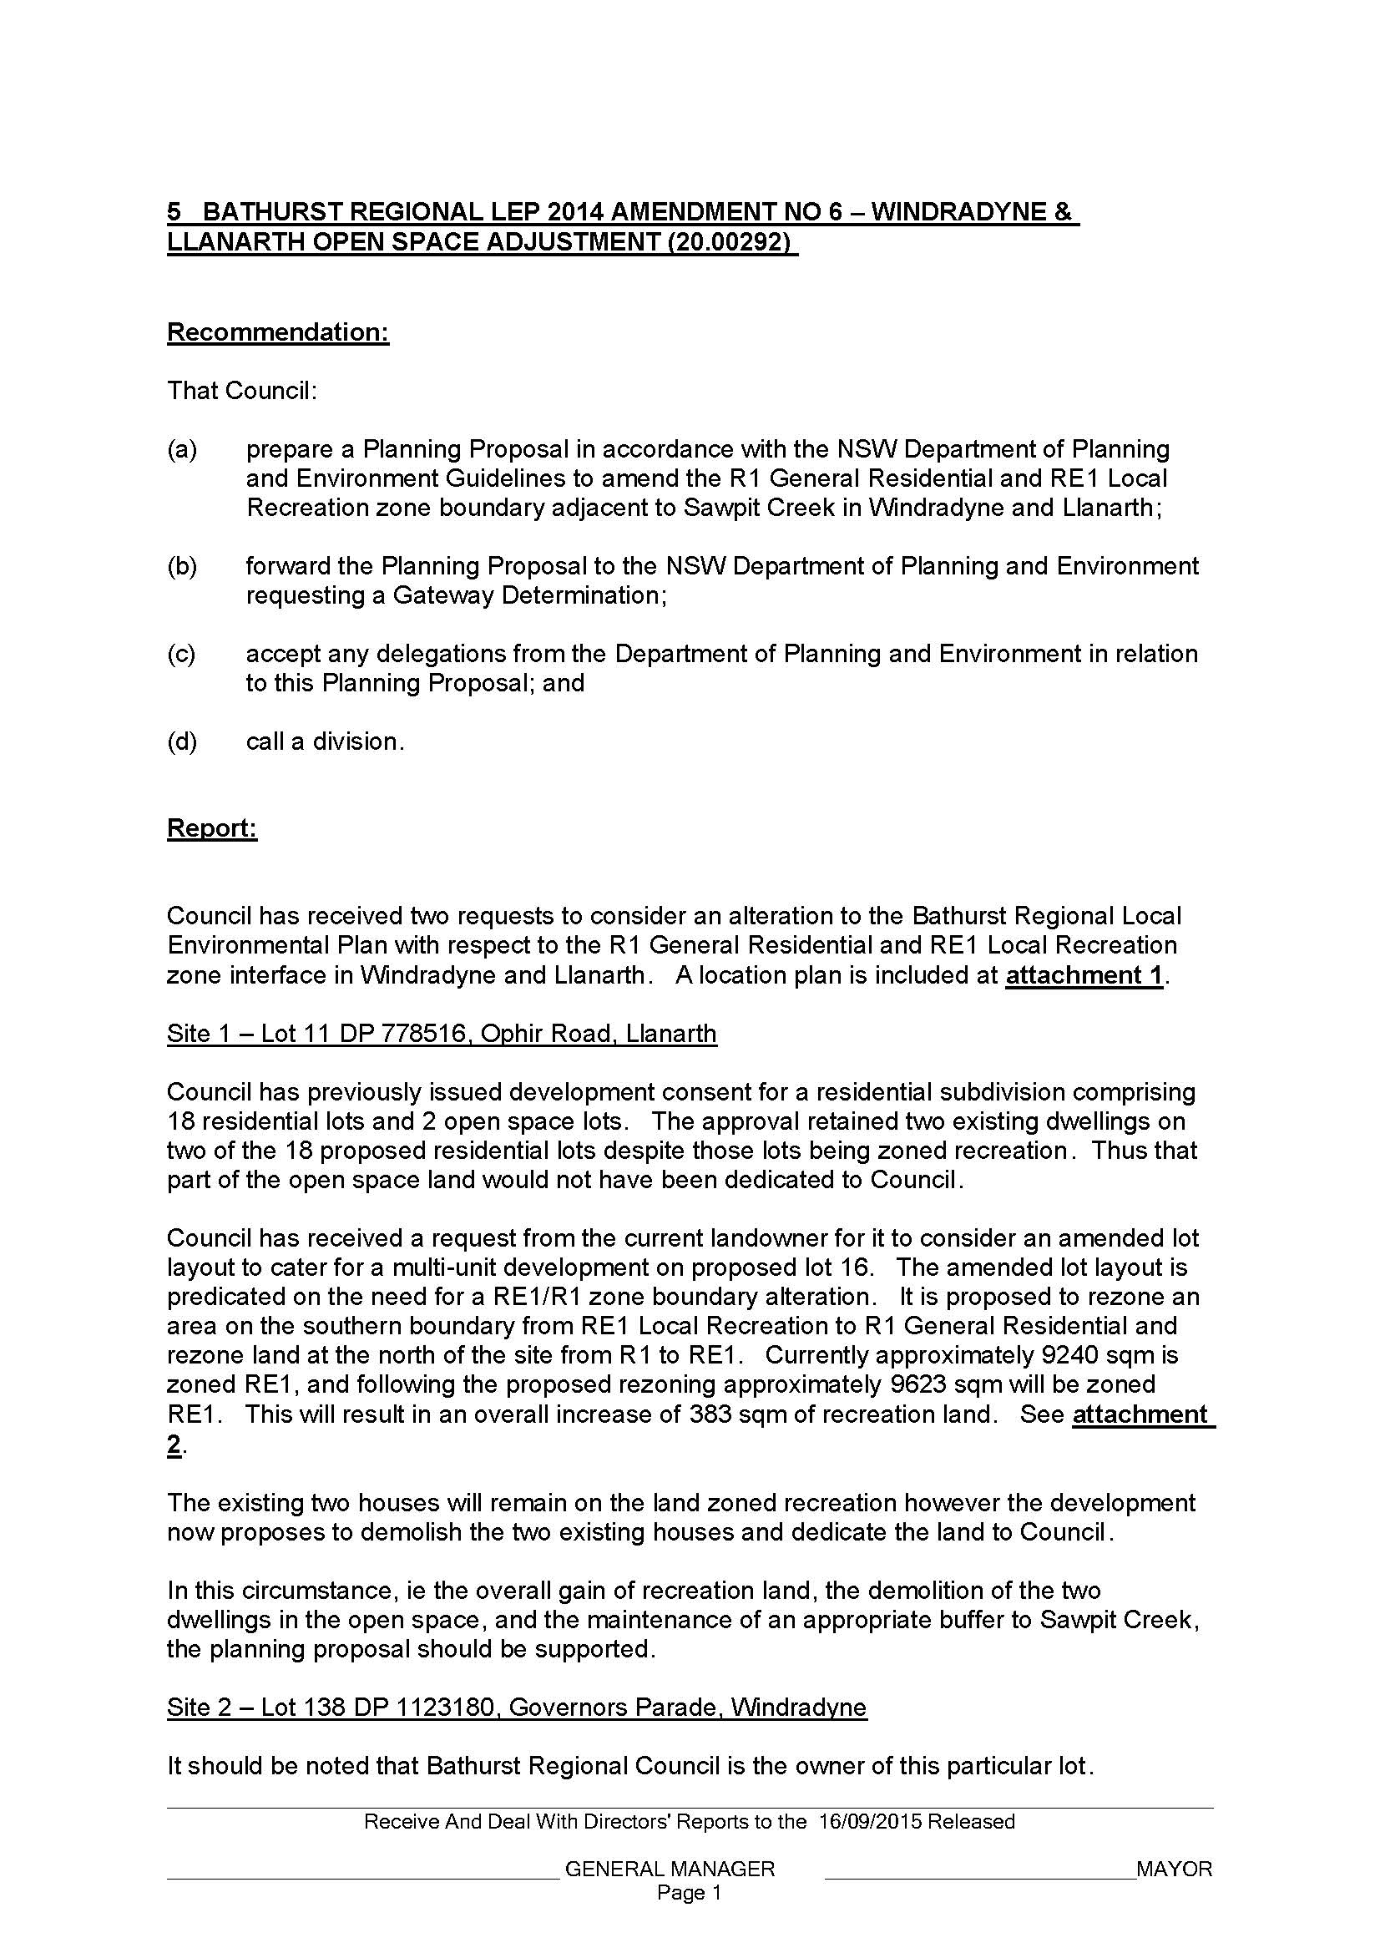

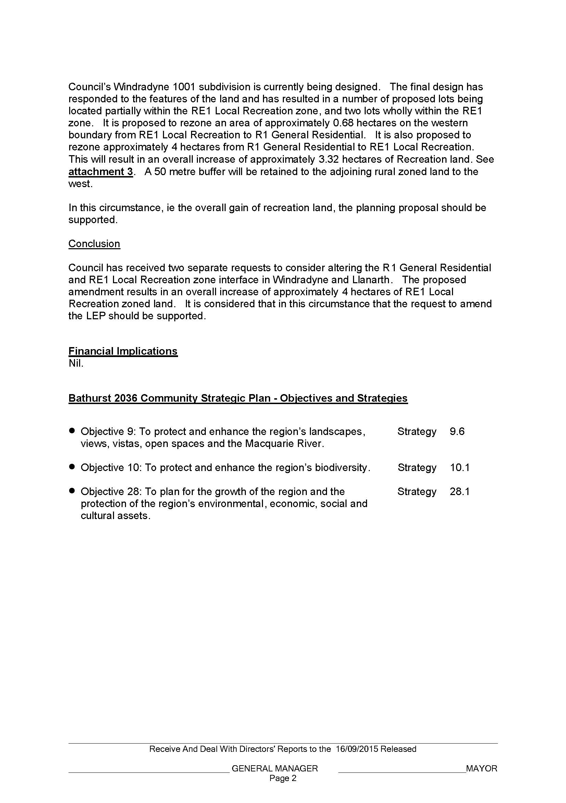

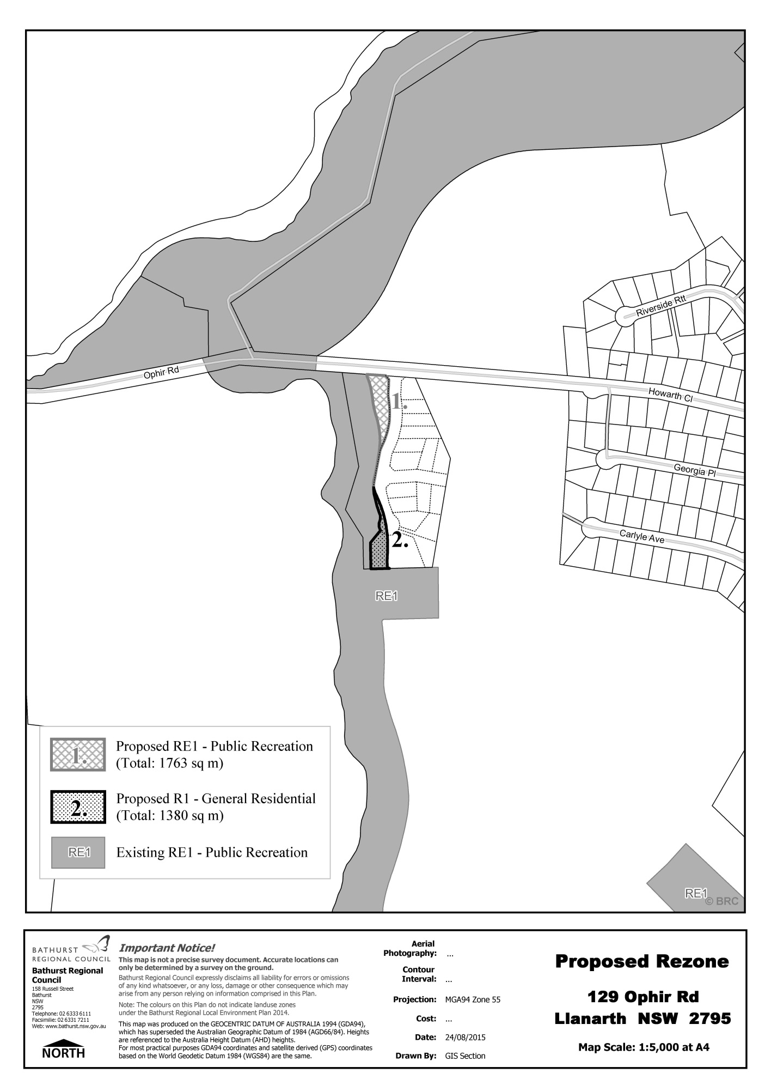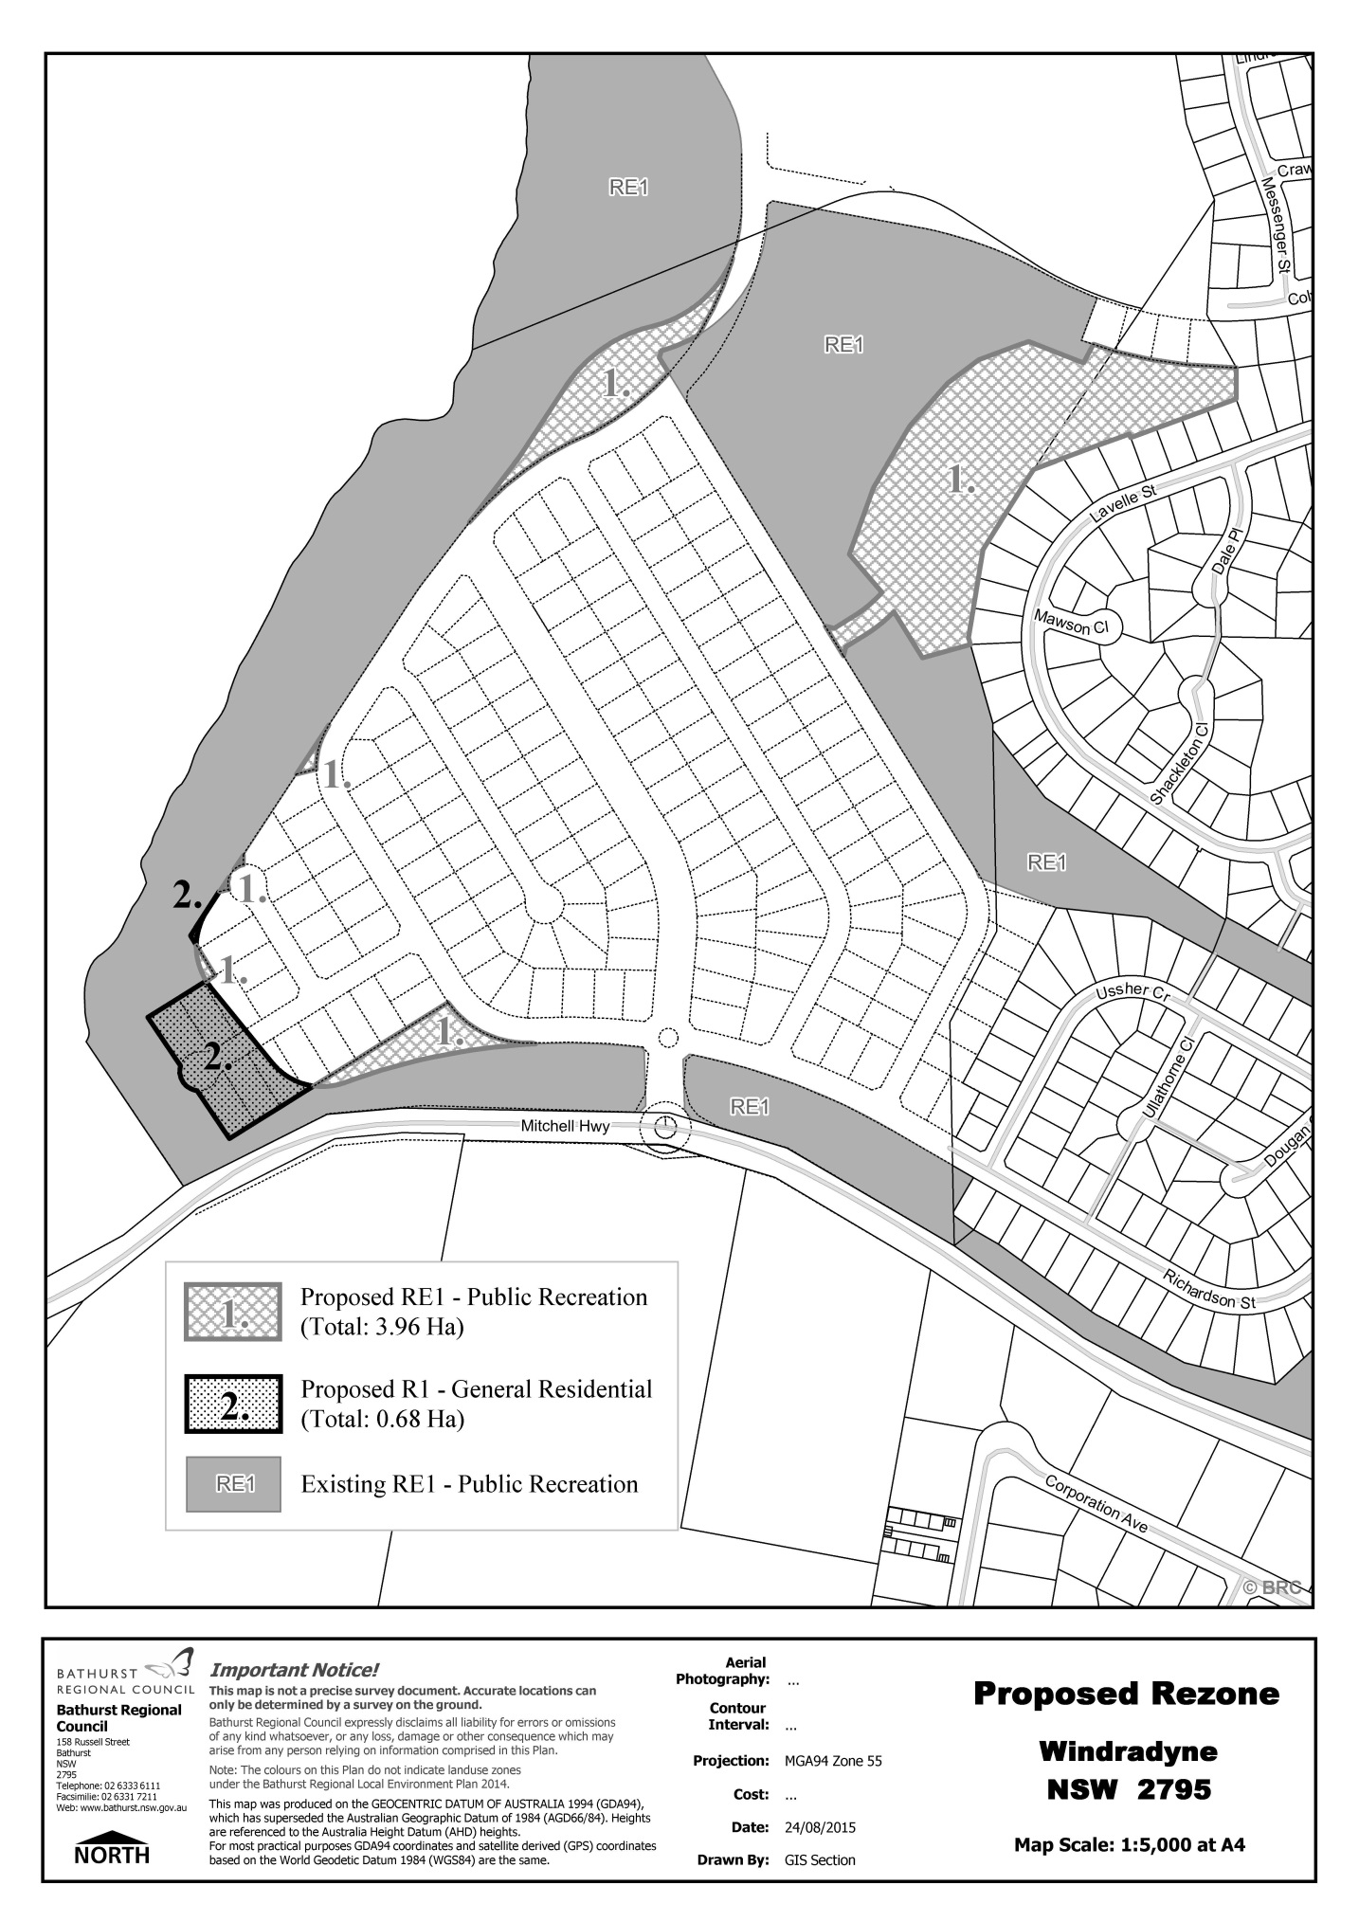

Site 1 – Lot 11 DP 778516, Ophir Road, Llanarth

Site 2 – Lot 138 DP 1123180, Governors Parade, Windradyne

